Financial Dashboard
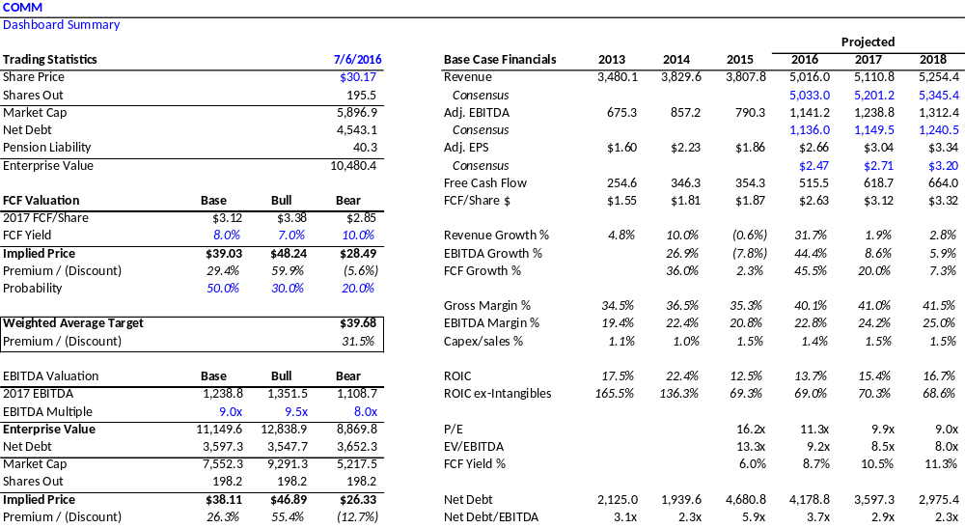
Executive Summary
Founded in 1976, CommScope (COMM) is a leading provider of telecom equipment and mission-critical infrastructure solutions. The firm holds #1 market share in nearly all markets where they compete. COMM manufactures 85% of the equipment they sell and is able to offer highly-customizable solutions to their customers (Fortune 500 companies and telco carriers) that help to not only entrench COMM’s competitive position, but do so profitably: the firm boasts 40% gross and 20% EBIT margins along with mid-teens ROIC (mid-60%’s ex-intangibles). Most importantly, margins and ROIC are currently depressed and inflecting higher as COMM finishes digesting a transformative $3B acquisition and capturing synergies. The “new COMM” will produce $3.00 and $3.25/share in FY17/FY18 levered free cash flow respectively – at an 8% FCF yield, COMM offers annualized returns of 20% over the next 24 months with limited downside.

Investment Highlights

- High-quality, cash-generative business with entrenched market position, favorable industry structure and ample opportunities to reinvest excess FCF. COMM boasts a 40-year track record of sustainable and predictable cash flow generation buoyed by minimal capex requirements (~1% of sales). The firm faces limited global competition which leads to pricing power as customers (AT&T, VZ) choose COMM based on reputation, agility, stability and customization (“one-stop shopping”) rather than just price.
- COMM’s moat is protected by multiple forms of barriers to entry. COMM’s fixed capital investments deter competition, with 30 manufacturing facilities in low-cost geographies like China or Mexico. The firm also has intangible barriers in their intellectual property (10,000+ patents), long-standing customer relationships, and outsized R&D spend relative to peers (4% of sales).
- COMM’s end markets are buoyed by powerful structural tailwinds. The rapid growth of data traffic, cloud services and streaming video has led to exponential demand for bandwidth and network densification. Customers like AT&T and Google are “hockey-sticking” fiber roll-outs to accommodate this interconnectivity growth and COMM is well-positioned in both wireless and fiber.
- Experienced management team with demonstrable track record of talented capital allocation and successful M&A integration. COMM’s management team has an average tenure of 25 years and has grown the business through multiple billion-dollar transformational acquisitions, with a history of under-promising and over-delivering on synergies. The firm’s corporate governance and compensation structure are excellent as the entire organization is incentivized to maximize free cash flow + EBIT.
- COMM stock offers compelling risk/reward and clear visibility into years of double-digit FCF compounding. As COMM integrates the recent $3B acquisition and de-leverages the balance sheet, free cash flow to equity will accrue from both margin expansion and lower interest expense. The firm has no near-term maturities with just $282m of notes due before 2020. The stock’s multiple is currently depressed vs. historical and should mean-revert as value is transferred from creditors to shareholders.
Business Overview - How does COMM make money?

- CommScope is comprised of two segments: Mobility (40% of revenue) and Connectivity (60% - split 25% outdoor, 35% indoor). These can essentially be simplified into wireless (Mobility) and fiber/broadband (Connectivity).
- The vast majority of CommScope’s revenue is from equipment sales and not services; management tends to describe the business as “telecom infrastructure plumbing” with company’s goal being “making the information superhighway wider and faster.”
- CommScope’s customer base is comprised of decades-long relationships with a host of Fortune 500 companies and carriers such as AT&T, Verizon, Comcast, T-Mobile and Google. The diversification of COMM’s product portfolio and geographic reach is a key strength and allows the firm to generate substantial free cash ($1.70/share trailing 5-year average) even if one segment slows due to shifting customer preferences - a recent example being wireless in 2014/15 as large carriers (AT&T) pushed out capex. COMM’s business model displayed impressive flexibility as they scaled back capacity and still reported a 20% FY15 EBIT margin.

Segment Overview:

- Mobility: COMM is a leader in wireless connectivity and sells coaxial cables and cell-tower antennas to wireless carriers along with DAS/small cell solutions to fill coverage gaps. This segment is largely comprised of the $2.6B Andrew acquisition from 2007.
  - COMM offers significant know-how in this space as “last mile” installation is complex: many antenna systems are placed in airports, garages, campuses, metro transit, on top of office buildings, or elsewhere on public streets, and this introduces both complexity and permitting issues with clients and municipalities.
  - Industry contacts have indicated that COMM’s ubiquitous presence is self-reinforcing and as equipment needs to be replaced, the simplest (and not necessarily cheapest) option is to upgrade the current CommScope equipment.
  - This segment has performed poorly as of late due to a weak capex environment (sales down 14% y/y in Q1’16) but comps should ease going forward. Despite lumpy earnings, the long-term fundamentals remain “up and to the right” with mobile data traffic expected to grow at a 53% CAGR through 2020.
  - Lee Ainslie, a long-time CommScope shareholder, once responded to claims that wireless capex is in secular decline by stating: “If you’ve tried to use an iPhone in New York City, you know that’s a ludicrous assumption.”
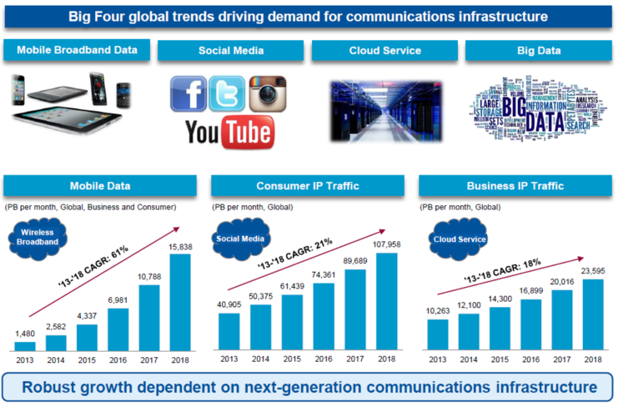
- Connectivity: Provides fiber solutions for residential networks, enterprises and data centers.
  - The majority of this segment is comprised of the recent $3B BNS acquisition (2015). Post-acquisition, the market for telco/enterprise fiber deployment has evolved into what is basically a duopoly between COMM and Corning.
  - The long-term tailwinds for fiber are stronger than wireless and has been described as “a modern day gold rush” due to the convergence of multiple powerful trends. Consumers simply are demanding faster broadband, in the forms of cord-cutting/SVOD, a secular shift of consumer Internet traffic to video (projected 80% by 2019), and cloud data center traffic projected to 4x as well over that same period.
    - Specialty telecom contractors like Dycom have stated they see opportunities that are “unprecedented for our industry…the breadth of demand is stunning.” “It is increasingly likely that It is increasingly likely that 2015 will be seen in retrospect as the initiation of a massive investment cycle in wireline networks reminiscent of, and perhaps more meaningful than, the one that occurred in the 1990’s.”
    - Companies like AT&T have “hockey-sticked” their estimates higher, from serving 1.6mm fiber customers in 2015 to a goal of 14 million by 2019. Relatively capex-unconstrained players like Google have entered the arena as well and are aggressively rolling out fiber nationwide. Both COMM management and third-party publications believe this market will grow in the high single-digits for the next several years.
  - Even if COMM simply maintains Connectivity market share, the stock can deliver double-digit free cash flow growth in a weak wireless environment.
Key Investment Factors
- CommScope enjoys a host of sustainable competitive advantages in both segments.
  - Barriers to entry are high due to incumbent scale, entrenched relationships with customers, mission-critical nature of projects, and intellectual property/patents.
  - COMM management indicated in a phone call that carrier industry consolidation is largely a positive for COMM rather than a negative. Many operators and cable MSO’s are positioning themselves for “Triple Play” offerings and COMM is one of the only players that can quickly fulfill a customized order of AT&T or Verizon’s magnitude.
  - What would a new, subscale entrant have to do to compete?
    - Offering a similar customizable set of solutions to COMM would require significant initial investments in both capex and working capital to construct manufacturing plants. However, without stable customer relationships and a reliable distribution network these under-utilized plants would weigh on profitability.
    - Bottlenecks also exist on the other end as finding and hiring trained installers for a product like fiber is slow and complicated. The “miniaturization” of equipment is crucial for installation as closer to the end-user as possible and is a CommScope specialty.
    - Last, while customers tend to be price-insensitive, COMM’s global presence adds to their economies of scale given access to low-cost materials and labor and allows them to pass savings on to the client. Any price increases passed on free up excess capital for COMM to invest in R&D or bolt-on M&A, widening their moat.

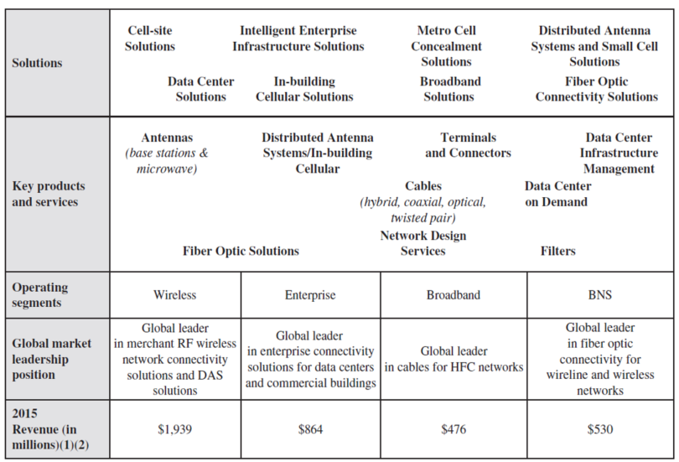
  - These scale advantages have led to an oligopoly market structure. COMM has one notable competitor in Germany (Kathrein) with the same breadth of products. Outside of that, the industry landscape is largely barren; Huawei is another competitor but US telcos are skeptical of trusting mission-critical data to the Chinese despite lower prices.

- Transformative M&A has masked the earnings power of the combined entity and COMM’s experienced management team (25 years on average) is well-equipped to deliver synergies in excess of guidance.
  - CommScope’s management has primarily grown the business through M&A and is no stranger to large-scale integration. The balance sheet’s ability to digest such large acquisitions is a testament to the stability of the business – mostly recently, COMM was taken private in 2011 by Carlyle with five turns of debt before being re-IPOed in late 2013.
  - Over the years, COMM’s management team has developed a reputation for under-promising and over-delivering on synergies, most notably on the Andrew deal in 2007 and Avaya’s Connectivity segment in 2004.
    - COMM’s synergy capture has historically been based on a combination of scale, exiting unprofitable product lines/geographies, simplifying ERP systems, and layering in price increases wherever possible. Management has stated they target 31 different synergy areas but does not list out each one individually.
  - In 2007, COMM paid $2.6B (90% cash) for Andrew Corp, which now comprises their wireless segment. Their original synergy target was $90-100m which was then raised to $115m in 2008 – an estimate management exceeded again in 2009.
    - When the acquisition was fully integrated in 2010, COMM had topped their original synergy guide by ~30%.
  - A similar scenario played out with the 2004 acquisition of Avaya’s connectivity business for $283m. While the scale of the acquisition was smaller, it doubled the firm’s revenues from $550m to over $1 billion.
    - From 2004 to 2007, consolidated operating margins expanded from 4.4% to 14.9%, or 1050 bps.
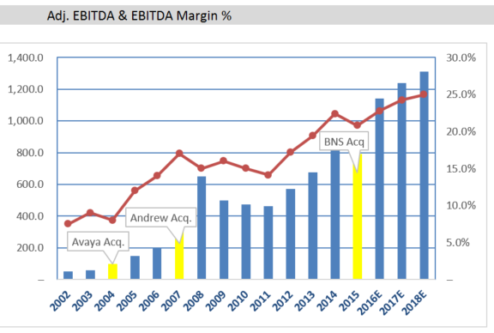
  - It is likely management uses the same playbook with the recent (August 2015) $3B acquisition of BNS.
  - Management already boosted their synergy guidance once since the acquisition, from $150m through 2018 up to $175m. Following this announcement, COO Randy Crenshaw stated at COMM’s investor day in May that they are “well ahead” of their targets thus far; a soft catalyst for COMM stock exists in management boosting guidance to $200m or $225m in upcoming quarters.

- The BNS acquisition offers three added benefits beyond strategic fit:
  - First, BNS smoothes the volatility of COMM’s earnings and should be beneficial to the stock’s multiple. Not only does BNS diversify the firm’s product offering (wireless is notoriously volatile) but also widens their geographic concentration. TE Connectivity is based in Switzerland and extends CommScope’s reach in Europe along with incremental revenue synergies via cross-selling.
  - Second, this multiple expansion is supplemented by COMM’s ability to rapidly de-lever the balance sheet and shift firm value to shareholders. COMM’s business model is highly cash flow-generative due to low capex requirements and this D&A mismatch (from acquisition intangibles) means COMM typically converts over 100% of net income into FCF.
  - We can see below how quickly COMM reduced leverage following both the Andrew acquisition in 2007 and the Carlyle LBO in 2011. While leverage appears high (~5.3x TTM) the firm has only $262m of the ~$5B debt balance due before 2020 and nearly $1B of current liquidity.
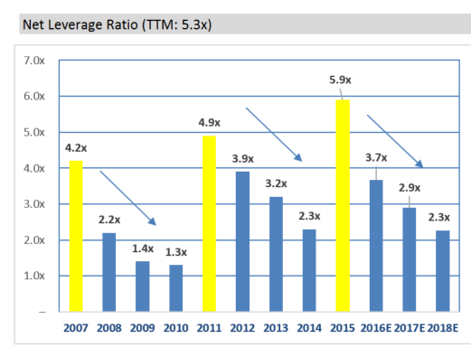

  - Third, this rapid debt paydown will not only boost returns on invested capital but also net margins and free cash flow to equity via lower interest expense.
    - Management is committed to paying down debt and has retired $300m of 2020 PIK notes in the current quarter (2Q16), which shaves nearly $20m or 7% off the firm’s annual interest expense.
  - COMM should hit their 3.5x target leverage ratio within 18 months, freeing up FCF to reinvest in organic growth opportunities, R&D, or further bolt-on M&A opportunities.
Base Case Model
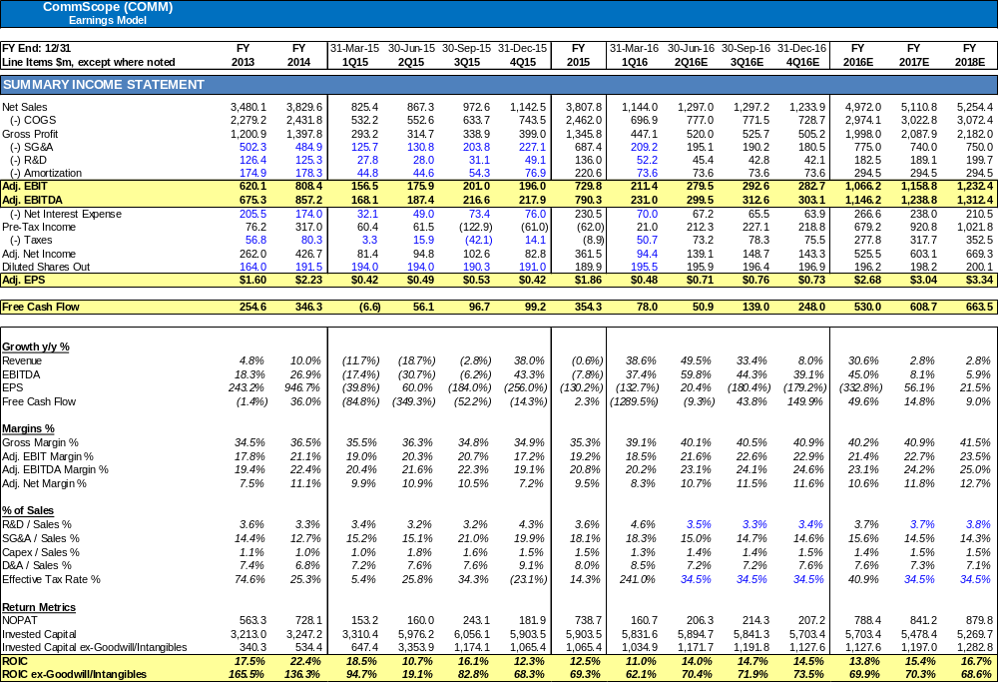
Top Ten Shareholder Overview (March 31, 2016)
- 1st: Carlyle Group (PE Sponsor): 32% ownership
- 2nd: Chieftain Capital: 8.3% of free float / 23.6% of portfolio
- 3rd: Maverick Capital: 7.1% of free float / 5.9% of portfolio
- 4th: FPR Partners: 5.3% of free float / 6.8% of portfolio
- 5th: Vanguard: 4.3% of free float
- 6th: Route One Investment Company (ex-Farallon investors): 3.3% of float / 9.2% of portfolio
- 7th: FMR LLC: 3.3% of free float
- 8th: Corvex: 2.6% of float, 2.3% of portfolio
- 9th: JPM: 2.5% of float
- 10th: Blue Ridge, 2% of float, 1.3% of portfolio
Historical Valuation: COMM is trading at the lower end of its range (11x forward EPS)
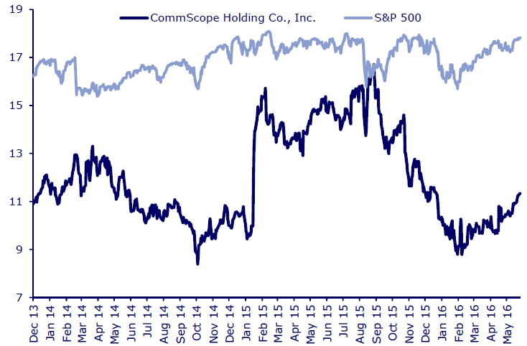
Risks and Mitigants
- Risk: COMM earnings are lumpy in nature as they only have 4-6 weeks of backlog visibility. Risk of blowing up quarter-to-quarter.
  - Mitigant: While earnings visibility is limited, the longer-term structural tailwinds are intact and should benefit an investor with a multi-year horizon. COMM management also indicated they hold quarterly “high-level” meetings with their larger customers (AT&T, Verizon) to ensure that their working capital forecasts are correct. Last, COMM has no significant customer concentration issues (above 10%) due to their diversification efforts.

- Risk: Despite secular trends, the business is still cyclical. With ~$5B in debt, CommScope’s leverage could be an issue.
  - Mitigant: No near-term maturities and just $262m of debt due before 2020, along with $1B in current liquidity.

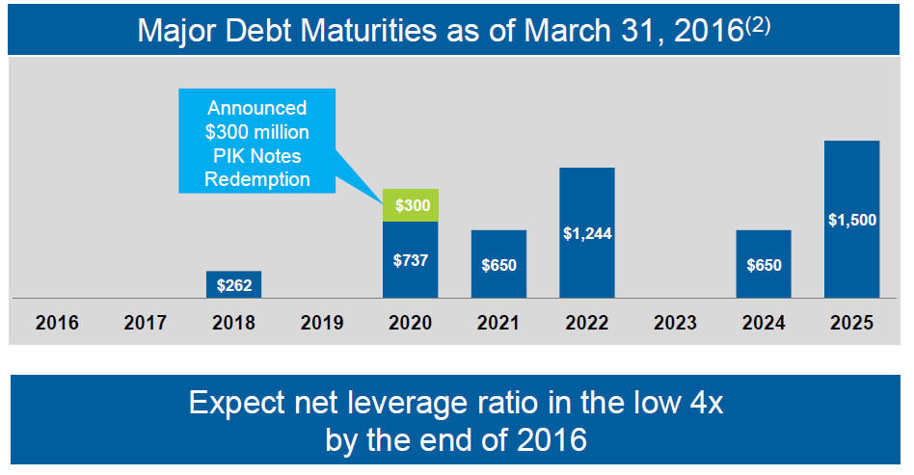
- Risk: Global telecom capex environment hit-or-miss outside of US, risks of potential slowdown in Europe
  - Mitigant: COMM’s diversification into fiber/broadband helps shield the business from a weak wireless environment. Cable MSO’s have begun ramping up investment (below) which should help pick up the slack.

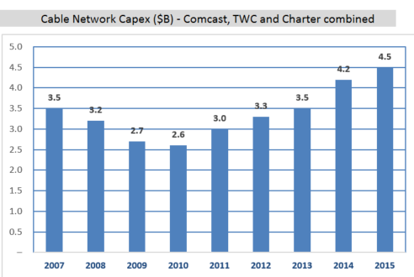
- Risk: Integration / M&A risk – synergies fail to materialize
  - Mitigant: Possible but unlikely given management track record. Goldman Sachs also ran a study (below) showing that component M&A synergies historically reach 10% of acquired company sales. BNS did $1.9B in LTM revs pre-deal so $190m is a reasonable base rate.

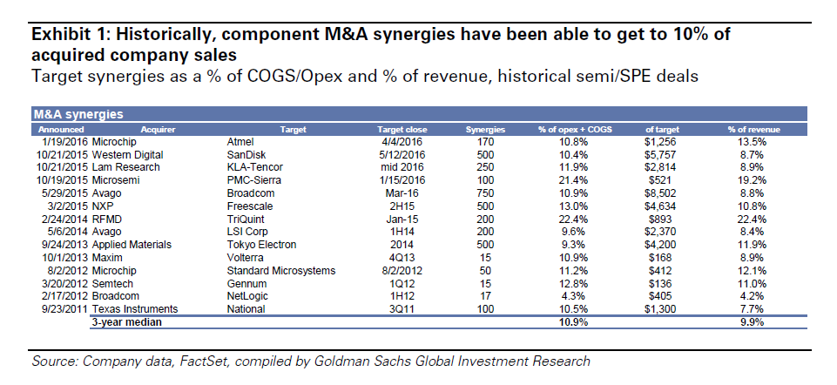
Appendix – Cash Flow Statement, Balance Sheet, Debt Schedule
